

Student Name……………………………………

MATHEMATICAL METHODS (CAS) UNITS 3 & 4

TRIAL EXAMINATION 1

2014

Reading Time: 15 minutes
Writing time: 1 hour

Instructions to students
This exam consists of 10 questions.
All questions should be answered in the spaces provided.
There is a total of 40 marks available.
The marks allocated to each of the questions are indicated throughout.
Students may not bring any calculators or notes into the exam.
Where an exact answer is required a decimal approximation will not be accepted.
Where more than one mark is allocated to a question, appropriate working must be shown.
Diagrams in this trial exam are not drawn to scale.
A formula sheet can be found on page 12 of this exam.

This paper has been prepared independently of the Victorian Curriculum and Assessment Authority to provide additional exam preparation for students. Although references have been reproduced with permission of the Victorian Curriculum and Assessment Authority, the publication is in no way connected with or endorsed by the Victorian Curriculum and Assessment Authority.

© THE HEFFERNAN GROUP 2014
This Trial Exam is licensed on a non transferable basis to the purchasing school. It may be copied by the school which has purchased it. This license does not permit distribution or copying of this Trial Exam by any other party.
Question 1 (4 marks)

- If 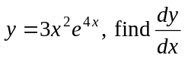. 2 marks

- For 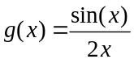, find 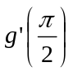. 2 marks

Question 2 (2 marks)

Find an antiderivative of 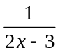 with respect to x.

Question 3 (2 marks)

Let 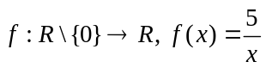.
Show that 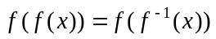 where 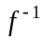 is the inverse of f.

Question 4 (5 marks)

- Solve 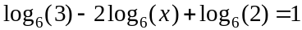 for x. 3 marks

- Solve 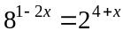 for x. 2 marks

Question 5 (2 marks)

Solve the equation 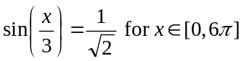.

Question 6 (5 marks)

For the discrete random variable X, with probability distribution shown below, 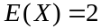.

x | 0 | 1 | 2 | 3 | 4
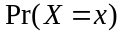 | 0.2 | 0.2 | 0.1 | 0.4 | 0.1

- Find the median of X. 1 mark

- Find 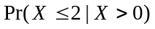. 2 marks

- Find the variance of X, 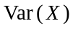. 2 marks

Question 7 (4 marks)

The continuous random variable X, has a probability density function given by

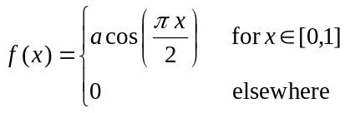

where a is a positive constant.

- Find the value of a. 3 marks

- Find the mode of X. 1 mark

Question 8 (6 marks)

The graph of 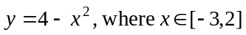 is shown below.
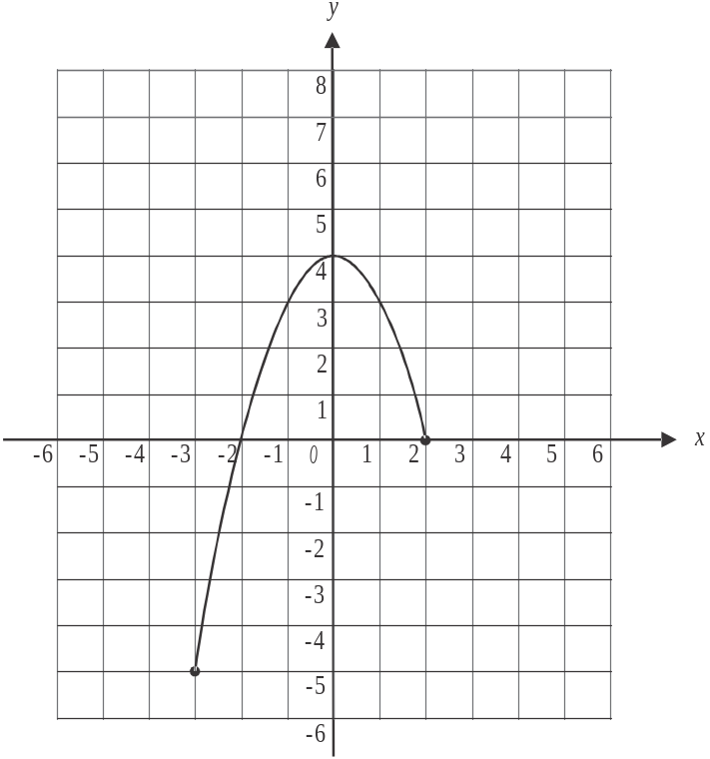

Let 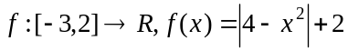.

- Sketch the graph of 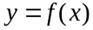 on the set of axes above. Indicate clearly the coordinates of the endpoints. 2 marks

- The graph of f is

  - translated 2 units in the negative direction of the y-axis
  - translated 2 units in the positive direction of the x-axis
  - dilated from the y-axis by a factor of

to become the graph of the function h.

For this function h, find

- the rule. 2 marks

- the domain. 1 mark

- the range. 1 mark

Question 9 (4 marks)

Let 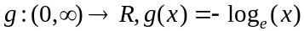.
The graph of g is shown below.
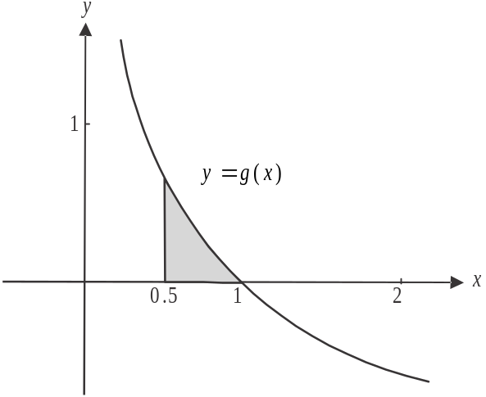

- Differentiate 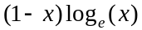 with respect to x. 1 mark

- Hence find the area of the shaded region shown above.
Express your answer in the form 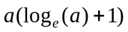 where a is a positive, real constant. 3 marks

Question 10 (6 marks)

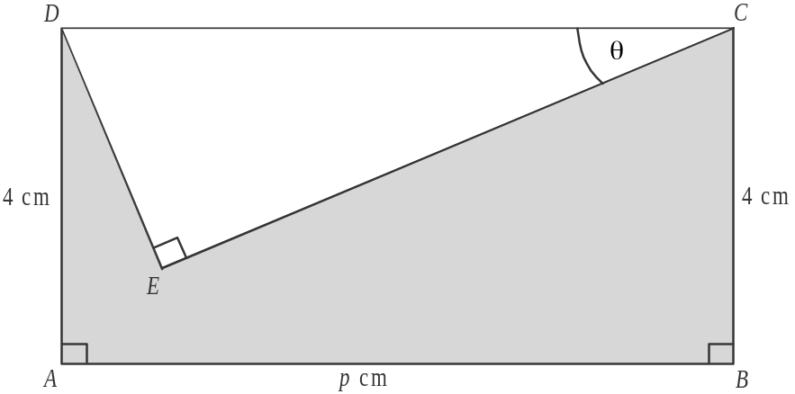

In the diagram above, ABCD is a rectangle and CDE is a right-angled triangle where 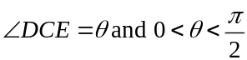.
Also, where p is a positive constant.

- Find an expression in terms of p and for

- DE 1 mark

- CE 1 mark

The area of the shaded region in the diagram is 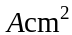.

- Find an expression for A in terms of p and . 1 mark

- Use the derivative 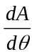 to find the value of when A is a minimum. 2 marks

- If the minimum area of the shaded region is 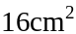, find the value of p. 1 mark

Mathematical Methods (CAS) Formulas

Mensuration

area of a trapezium: 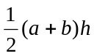 volume of a pyramid: 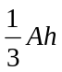
curved surface area of a cylinder: 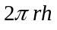 volume of a sphere: 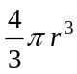
volume of a cylinder: 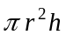 area of a triangle: 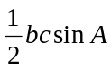
volume of a cone: 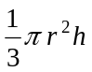

Calculus
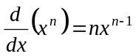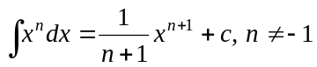
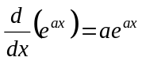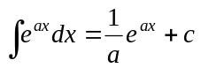
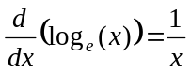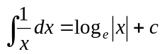
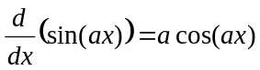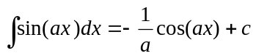
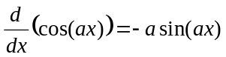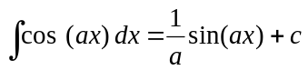
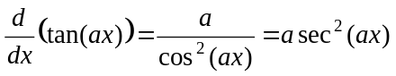
product rule: 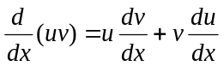 quotient rule: 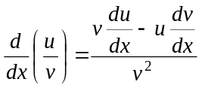
chain rule: 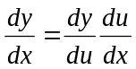 approximation: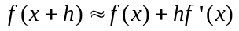

Probability
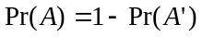
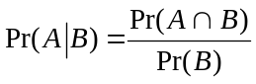 transition matrices: 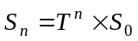
mean: 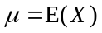 variance:

probability distribution |  | mean | variance
discrete | 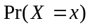=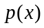 | 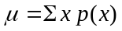 | 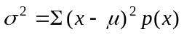
continuous | 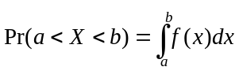 | 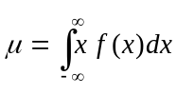 | 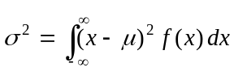

Mathematics Formula Sheets reproduced by permission; © VCAA 2013. The VCAA does not endorse or make any warranties regarding this study resource. Current and past VCAA VCE® exams and related content can be accessed directly at www.vcaa.vic.edu.au

